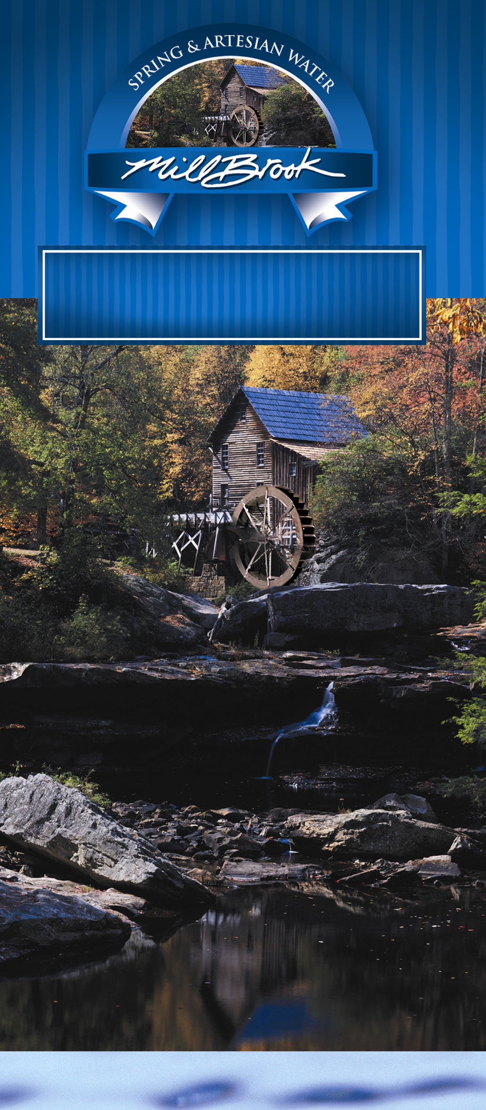
Free Water? Just ask us how
We offer the best of both bulk and bottled water with our unsurpassed service!
**Our Premium bulk water deliver service, No more bottles to lift, store and carry
**Our 5 gallon premium drinking water delivery service

